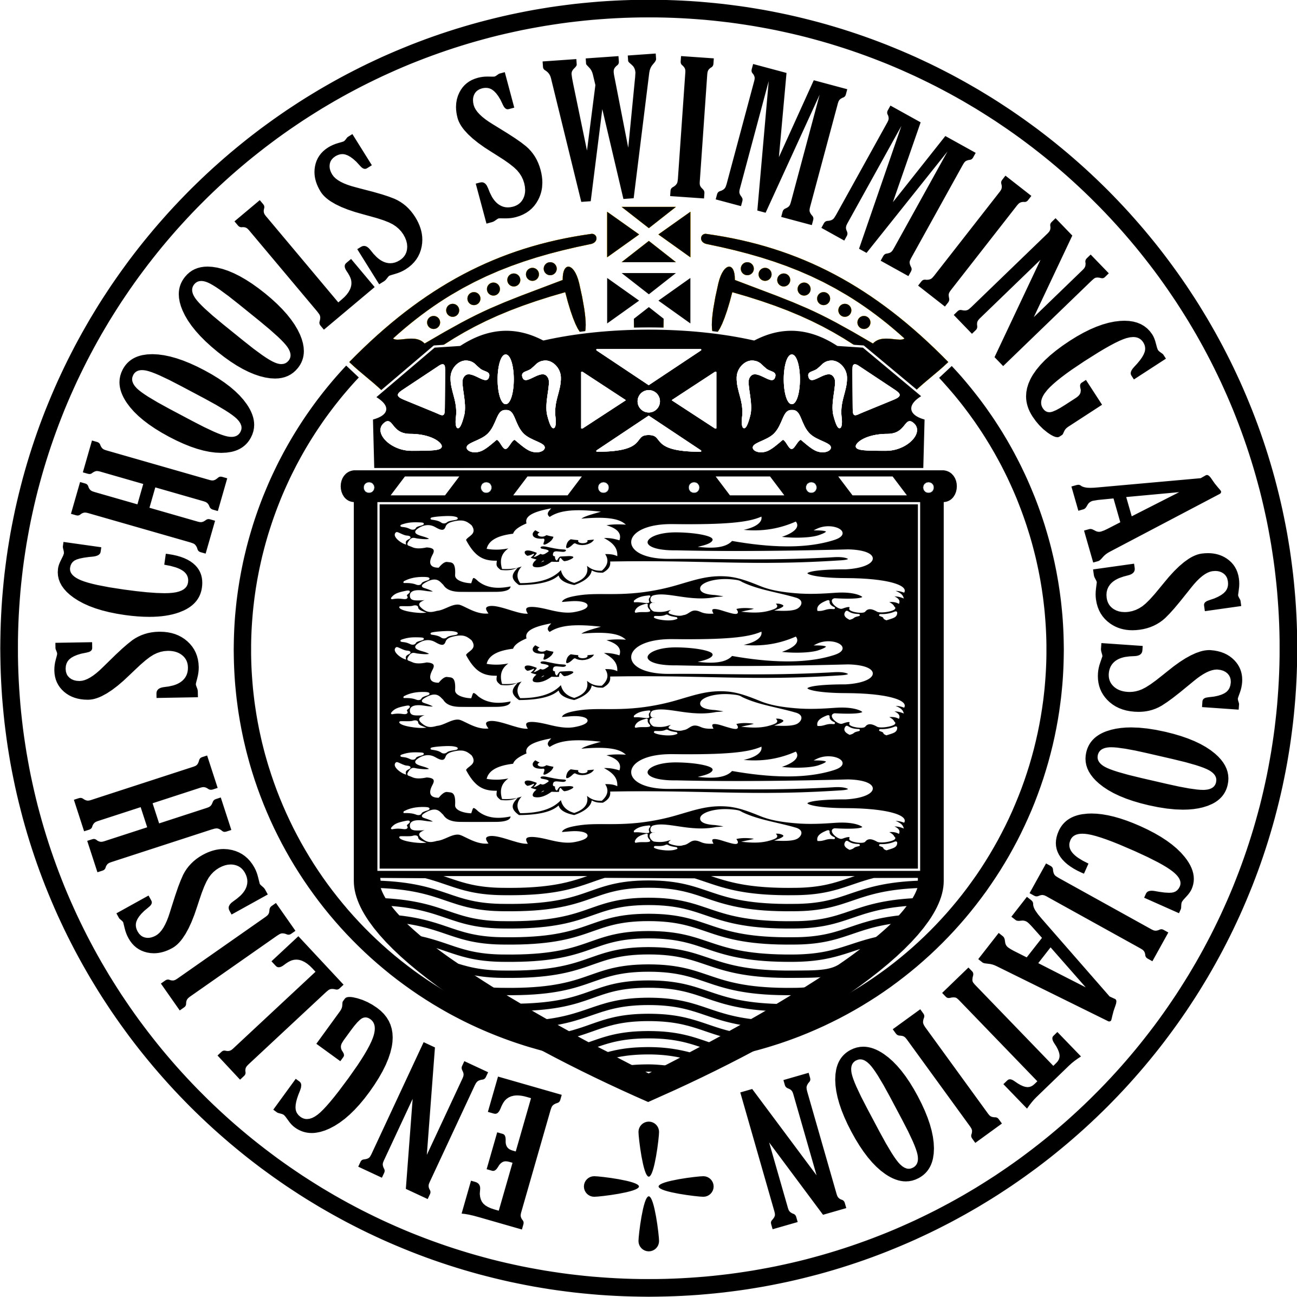26th NATIONAL SWIMMING

CHAMPIONSHIPS FOR

PRIMARY SCHOOLS 2022

TEAM LIST – SE DIVISION ROUND

School:
Division:

 | 4 x 25m Freestyle Relay | 4 x 25m Mixed Stroke Relay
Open Schools Boys Team
Open Schools Girls Team
Medium Schools Team
Small Schools Team

Event:
(Please tick relevant box)

 | FULL NAME  (PLEASE USE BLOCK CAPITALS) | DATE OF BIRTH  (from 1/9/2010 to31/8/2012) | SCHOOL  YEAR
1
2
3
4
Reserve

Adult in charge, on the poolside:

I confirm that the above pupils are on the full-time roll of the above School and
that their dates of birth, as given above, are correct.

Signature Date
(Teacher in charge)

A SEPARATE TEAM LIST MUST BE SUBMITTED
AT EACH STAGE OF THE CHAMPIONSHIPS

THIS FORM, DULY COMPLETED, MUST BE HANDED IN TO THE SIGN-IN TABLE AT THE SOUTH EAST CHAMPIONSHIPS,
ON FRIDAY 7th MAY 2022, NO LATER THAN 5:30pm

